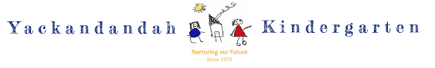
PHILOSOPHY STATEMENT 2026
Yackandandah Kindergarten belongs to the community of Yackandandah and surrounding areas. We are committed to providing high-quality, inclusive early childhood education where every child feels safe, valued, and supported.
We believe children learn best through a balance of structured and unstructured play. Through child-led exploration, guided learning experiences, nature play, and daily routines, children develop confidence, curiosity, independence, and important life skills.
Our bush and outdoor environments support children’s physical, social, emotional, and cognitive development, while helping them build a strong connection with nature, sustainability, and the local community.
We recognise that consistent routines provide children with a sense of security, wellbeing, and belonging. We create warm and caring environments where children feel confident to learn, explore, and grow.
We value each child as an individual and celebrate diversity, acceptance, and inclusion. We respect children’s unique strengths, interests, cultures, and backgrounds.
We acknowledge families as children’s first teachers and value strong partnerships with families and the wider community. By working together through collaboration and mutual respect, we create the best outcomes for children.
We are committed to child safety and wellbeing and ensure all children are protected, respected, and heard.

Our Core Values

- Honesty
- Respect
- Responsibility
- Fairness
- Compassion
- Acceptance
- Diversity
- Learning
- Safety
- Collaboration

ASSOCIATED POLICIES / DOCUMENTS:
All Kindergarten Policies will consider the Philosophy Statement and identified Values which are presented in the Yackandandah Kindergarten Quality Improvement Plan 2023.
REVIEW
This Philosophy Statement will be reviewed annually in consultation with staff, families, and the kindergarten community.

