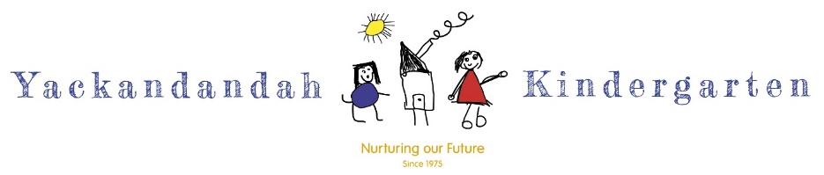

UNIFORM ORDER FORM

Parent Name: | Order Date:
Child’s Name: | □ 3yo Program □ 4yo Program
Email: | Phone:

GARMENT | SIZES  Circle size choice | COLOURS  Circle colour preference | PRICE | QUANTITY  ORDERED
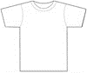  UNISEX T-SHIRT  100% Cotton 180gsm | - 4  - 6 | - KELLY GREEN  - ORANGE  - ROYAL BLUE [size 4 only]  - LIME  - RED  - PURPLE  - HOT PINK  - AZURE BLUE [size 4 only]  - GRAPE [size 4 only] | $20 EACH
UNISEX W’CHEATER Cotton/Poly 340gsm | - 4  - 6 | - HOT PINK  - RED  - KELLY GREEN  - ORANGE  - ROYAL BLUE  - PURPLE [size 4 only] | $27 EACH
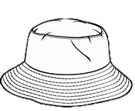  BUCKET HAT | - 54cm  This size fits most pre-school age children. | - YELLOW  - AZURE BLUE  - RED  - NAVY  - PINK [PALE & HOT]  - BOTTLE GREEN  - ROYAL BLUE | $18 EACH | Indicate 1st and 2nd colour choice preference  1st:  2nd:

Order Forms to be returned to the Kinder Office for processing. If cash payment is made at the Kinder, the uniform can usually be supplied the same day. If paying funds transfer to the school, the uniform is provided once we see either an on-line receipt on your phone or receive a paper receipt from the School.

PAYMENT METHOD:
CASH □  (Payable to Yack Primary School OR the Kindergarten) | FUNDS TRANSFER □ (To Yack Primary School)  Yackandandah Primary School 02 6027 1431  Bank: Westpac BSB: 033-222 Account: 018848  [use the reference “Kinder Uniform” PLUS YOUR NAME]

TOTAL AMOUNT OF ORDER $____________
Office Use Only
Order & Payment received on: | Order placed with Supplier:
 | Ordered supplied to parent:

