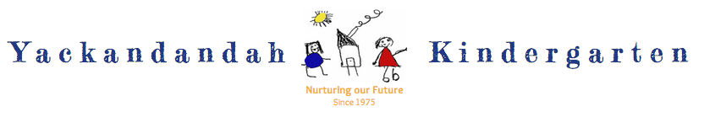
EXPRESSION OF INTEREST FOR ENROLMENT IN 2025
EOI RECEIVED:

Child’s Name

Child’s Date of Birth

Address

Email Address

Parent Names

Home Phone Work/Mobile

THE 2025 PROGRAM/S I AM INTERESTED IN ARE:

Fully Govt Funded 3yo Kindergarten - 15 hours/pw over 2 days

Fully Govt Funded 4yo & over Pre-School - 15 hours over 2 days attendance p/w

Non-funded BUSH KINDER PROGRAM [3yo & 4yo sessions]
YES NO

YACKANDANDAH KINDERGARTEN
30 ISAACS AVENUE, YACKANDANDAH 3749
yackandandah.kin@kindergarten.vic.gov.au
www.yackandandahkinder.com.au
Please return this completed form via email or post.
If you need any further information about our
Kinder, you can reach us on 6027 1560.
Enrolment Information Handbook and application
forms will be available from our website or the kinder
from the end of April.

General Enrolment Procedures
Yackandandah Kindergarten
[Reference: Kindergarten Enrolment Policy 2023 Document]

1.2 Selection Process

Age of Children (see 1.11P Eligible Children)
There is a maximum of 33 places available for 4 year old Pre-School Program.
There is a maximum of 22 places available for 3 year old Kindergarten Program.

Where there is pressure for places, priority will be given to people who reside in Yackandandah, Osbornes Flat, Staghorn Flat, Indigo Valley and Wooragee.
A postcode criteria is used to assess eligibility for kindergarten.

Changes to contact details or year of attendance will need to be advised directly to the Kindergarten Administration Officer.

1.3 Session Allocation

Sessions will be allocated to each child accepting a place. Parents will be given the opportunity to submit their preferred sessions upon payment of the Enrolment fee. The Administration Officer and Approved Provider/ Principal will be responsible for managing the allocation of sessions. The process of session allocation is a time-consuming task and not all requests can be met. Some flexibility by parents is usually required. A waiting list is maintained for those children who do not succeed in gaining their first session preference. If a vacancy occurs for a preferred session, the Administration Officer will direct the offer to the first family on the waiting list.

Session allocation for each child is determined by taking into account parent preferences and:
  - original enrolment application date
  - availability of requested preferences
  - the needs of all children
  - maintaining sufficient children allocated for each session of Kindergarten to be viable to run.

Each family will be notified of their allocated session as soon as possible. All requests for change must be directed to the Administration Officer, Educational Leader or Approved Provider.

Requests for occasional swapping of days, as a result of family occasions or public holidays occurring on their child’s nominated days, will be considered by Approved Provider/ Principal, Administration Officer and Educational leader.

Fees are still payable for any missed session due to illness or other inability to attend.

